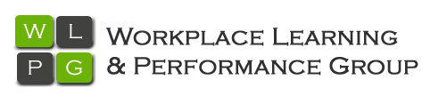

Excellence in Management

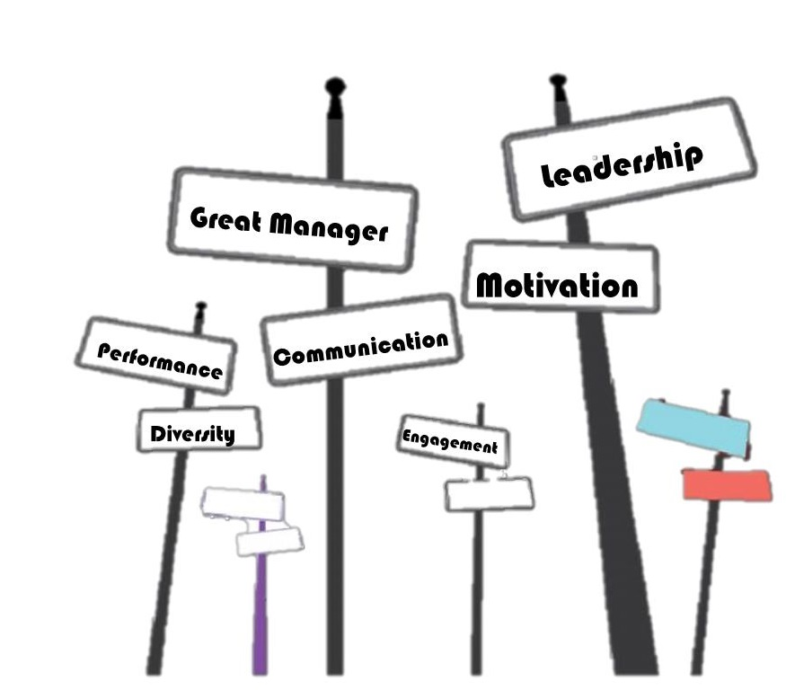
………
…….
…….

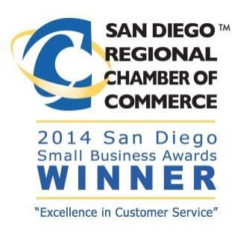
WLPG
Certified Training Program

About WLPG

The Workplace Learning and Performance Group (WLPG) is a management consulting and training firm dedicated to teaching individuals and organizations to improve their performance so they can achieve their desired results. It is our mission to help you manage your business with a clear vision for the future.

We develop customized solutions to fit your organizational needs. Our consultants have extensive experience working with organizations in many fields such as: high tech, aerospace, large and small business, government, academia, nonprofit, and associations, and focus on management coaching, leadership training, diversity creating, resilience building, strategic planning and improving performance.

President of WLPG
Maureen Orey
617-847-4748
maureen@wlpgroup.com

Visit our official website and learn more about us http://www.wlpgroup.com/

Maureen is an engaging international speaker, expert facilitator and executive coach, her passion is to work with business leaders to help them improve their performance so they can achieve their desired results!
With over twenty-five years’ experience, her specialties include leadership and
management development, coaching, strategic planning, diversity awareness and communication.

Excellence in Management
Program Description

In this dynamic program, participants will learn the basic human resources skills and
Knowledge every supervisor and manager needs to tackle the complex challenges in today’s workplace. Participants will develop the supervisory skills they need to increase performance and exceed business objectives, be more effective in the hiring and training process, understand how to handle legal issues, enhance their interpersonal communication skills, practice coaching to improve employee performance, and network with other participants to share ideas.

- Develop the supervisory skills you need to increase performance and exceed business objectives
- Enhance your effectiveness in hiring and training employees
- Understand employment law and how to handle difficult legal issues
- Increase the quality of your interpersonal communications
- Improve employee performance through coaching
- Network with other participants and develop ideas that will work for you

Courses Include

- How to Be an Effective Leader
In this session you will learn the elements of effective leadership and how to assess relationships with employees. You will learn the importance of building a positive working environment and managing meetings effectively. You will explore aspects of today’s organizations and how people interact at work.

- How to Manage a Diverse Workplace
Identify key aspects of accommodating diversity in today’s work environment and explore best practices of communicating and managing a diverse team.

- How to Build Your Emotional Intelligence
In this session you will explore the key factors of EQ, determine how to improve your self-awareness as well as your awareness of others

- How to Understand Employment Law
Learn about the laws that impact the employment relationship. Emphasis is placed on leave of absence laws, disability accommodation, discrimination, wage and hour issues, and where to find assistance with other complex issues.

- How to Prevent Sexual Harassment
Learn about identifying behaviors that constitute sexual harassment, and recognize that the USE policy prohibits sexual harassment; also discuss strategies to prevent sexual harassment.
- How to Interview and Select the Best Employees
Learn new recruitment and selection strategies and how to fill vacant jobs in a timely and successful manner. Also learn how to identify the behavioral characteristics to focus on in the interview, while developing your skills as an effective interviewer

- How to Motivate Employees
Learn the how and why of current pay practices behind your own organization’s compensation policies. Identify strategies for increasing the motivational spirit of your work team, including financial and non-financial ideas for recognizing your team members

- How to Listen and Communicate Effectively
Learn strategies for effective communication and dealing with difficult people. Discover effective ways to organize and communicate in staff meetings and one-on-one with employees. Understand key methods of resolving difficult situations through coaching and problem-solving techniques

- How to Train Employees on the Job
Learn about the different ways employees learn and the variety of training techniques you can use, how to develop an employee training plan, and how to create and use job aids to improve employee performance.

- How to Manage Employee Performance
Learn how to develop criteria and performance standards to measure an employee’s work, how to deal with conflict situations, and how to avoid violence in the workplace. You’ll learn how to conduct an effective performance evaluation conference (even with a poor performer), and practice conducting conferences.

- How to Manage Multiple Priorities
Learn how to balance the many priorities you are faced with every day at work. This session will provide the tools for taking control of your tasks and deadlines; managing time more effectively by learning to prioritize; and earning respect by remaining calm even during the most stressful times. You will develop a plan of action to become more productive and satisfied in all areas of your life

